Assignment –1

Creating sample tables and inserting values.

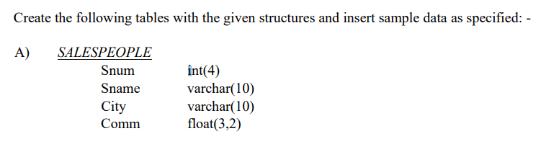

create table SALESPEOPLE( Snum INT(4), Sname VARCHAR(10), City VARCHAR(10) , Comm FLOAT(3,2));

insert into salespeople values(1001, 'Peel' , 'London' , .12);

insert into salespeople values(1002, 'Serres','San Jose', .13);

insert into salespeople values(1004, 'Motika','London', .11),

-> (1007,'Rifkin', 'Barcelona', .15),

-> (1003, 'Axelrod', 'New York', .10);

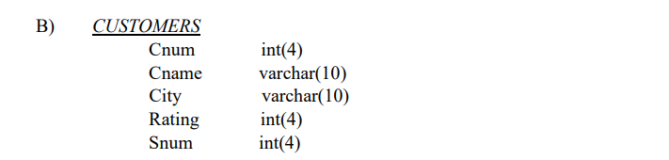

create table CUSTOMERS(CNUM INT(4), CNAME VARCHAR(10), CITY VARCHAR(10), RATING INT(4), SNUM INT(4));

INSERT INTO CUSTOMERS VALUES(2001, 'Hoffman', 'London', 100, 1001),

-> (2002, 'Giovanni', 'Rome', 200, 1003),

-> (2003, 'Liu', 'San Jose', 200, 1002),

-> (2004, 'Grass', 'Berlin', 300, 1002),

-> (2006, 'Clemens', 'London', 100, 1001),

-> (2008, 'Cisneros', 'San Jose', 300, 1007),

-> (2007, 'Pereira', 'Rome', 100, 1004);

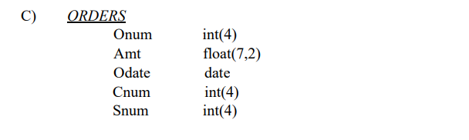

CREATE TABLE ORDERS(Onum INT(4), Amt FLOAT(7,2), Odate DATE, Cnum INT(4), Snum INT(4));

INSERT INTO ORDERS VALUES(3001, 18.69, '1990-10-03', 2008, 1007),

-> (3003, 767.19, '1990-10-03', 2001, 1001),

-> (3002, 1900.10, '1990-10-03', 2007, 1004),

-> (3005, 5160.45, '1990-10-03', 2003, 1002),

-> (3006, 1098.16, '1990-10-03', 2008, 1007),

-> (3009, 1713.23, '1990-10-04', 2002, 1003),

-> (3007, 75.75, '1990-10-04', 2004, 1002),

-> (3008, 4723.00, '1990-10-05', 2006, 1001),

-> (3010, 1309.95, '1990-10-06', 2004, 1002),

-> (3011, 9891.88, '1990-10-06', 2006, 1001);